**FACE RECOGNITION - AUTOMATIC ATTENDANCE SYSTEM**

KEYWORDS:

- Face detection, Face Recognition, Automatic Attendance,

INTRODUCTION:

Face recognition is an important application of image processing owing to its use in many

fields. Identification of individuals in an organization for the purpose of attendance is one such

application of face recognition. This application can be used in **schools ,offices** etc. This application improves the **maintenance and monitoring of attendance records** , while also making it easier for a user to easily access and analyze these records.

OBJECTIVES:

- Automatically detects faces and marks attendance in database without any need for a person to do anything manually, i.e. it is fully automated.

-**Easily Identifies unknown members**.

Touch-less Face recognition based Attendance

Face Recognition – Project

1. Benefits

* Automated and **accurate**
* **Saves Time**
* Increases **Security**
* **Prevents Loss of Productivity**
* **Touch-less - no physical contact , therefore hygienic**
* Automated time tracking system
* **Saves labor cost**
* Simple and **easy installation**
* **Response time: less than a second**

1. Features included

* fast face processing,
* live face detection,
* face image quality determination,
* tolerance to face postures,
* identification capacity, fast face matching,
* compact face features template,

1. First time the application launches – It shows a page asking to enter the KEY

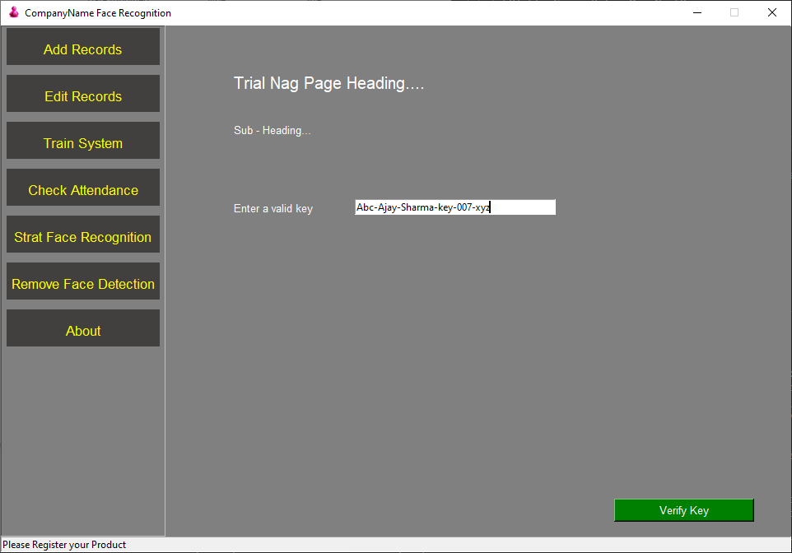

**Note – Without verifying the login process , the user cannot move to any tab/ button**

1. After successfully verifying the key on server – it Registers New User

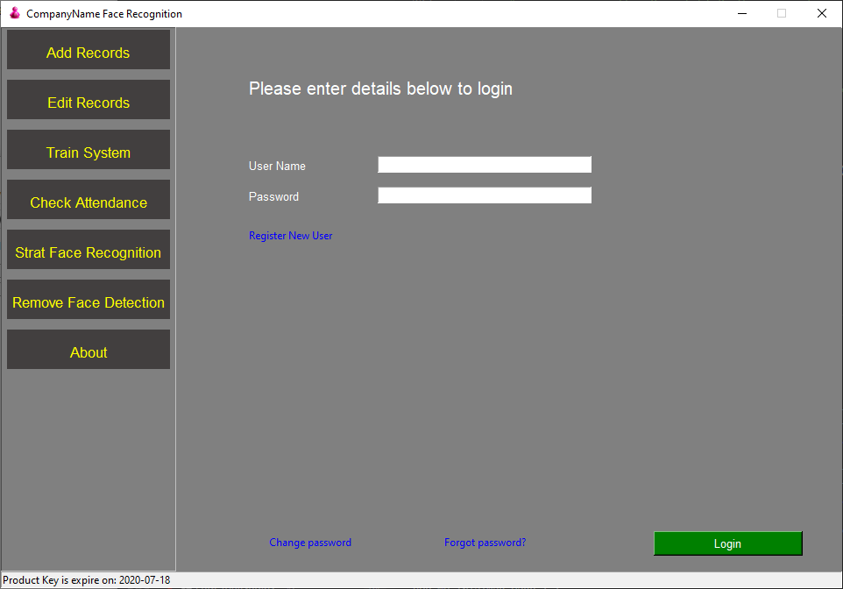

1. If a user tries to login without registering first, then she/he is not allowed to do so .

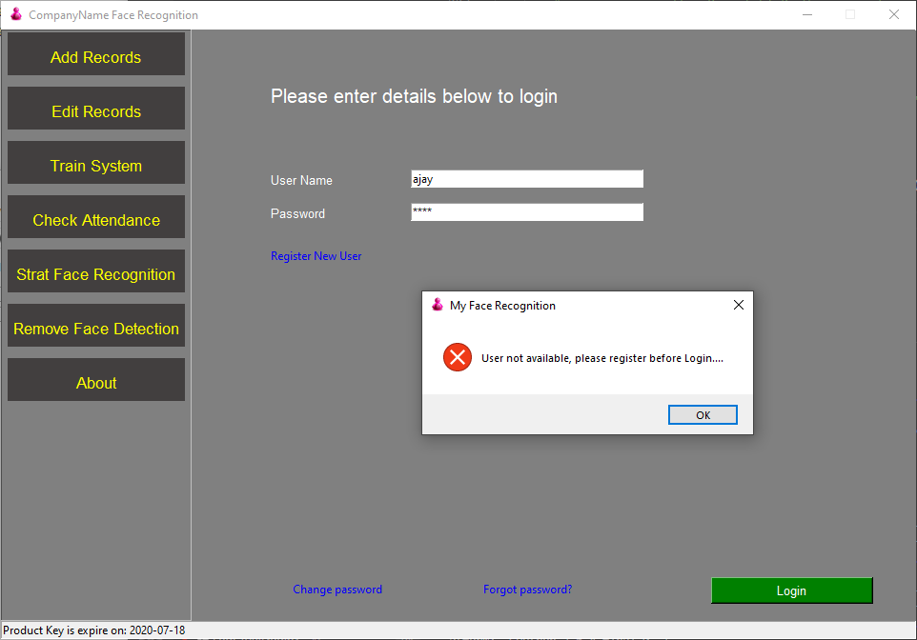

1. Registering a New User page

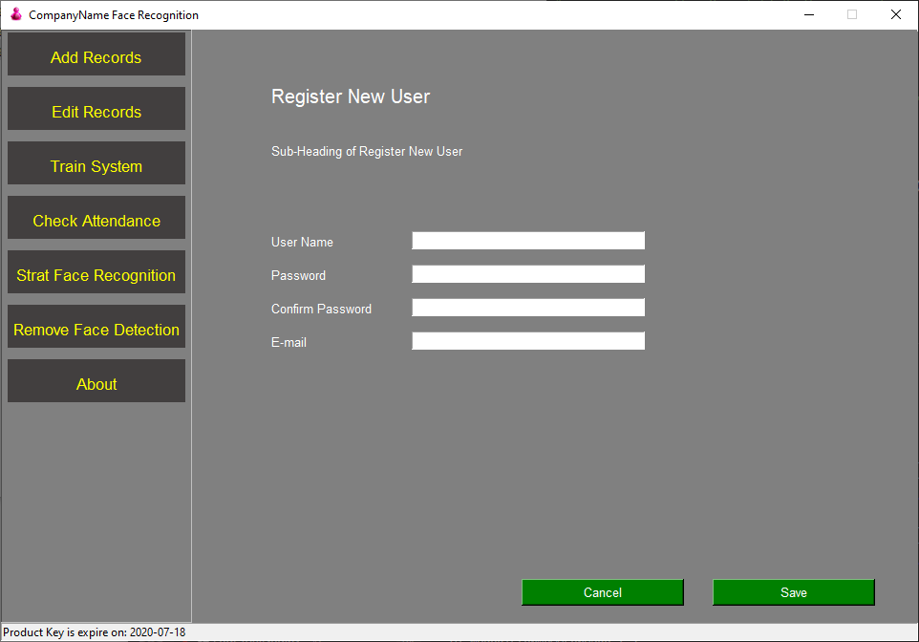

5.

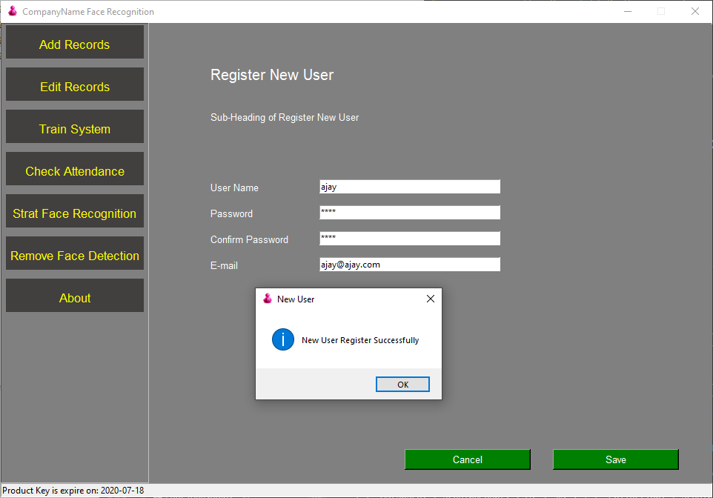

1. If the user enters wrong password……….

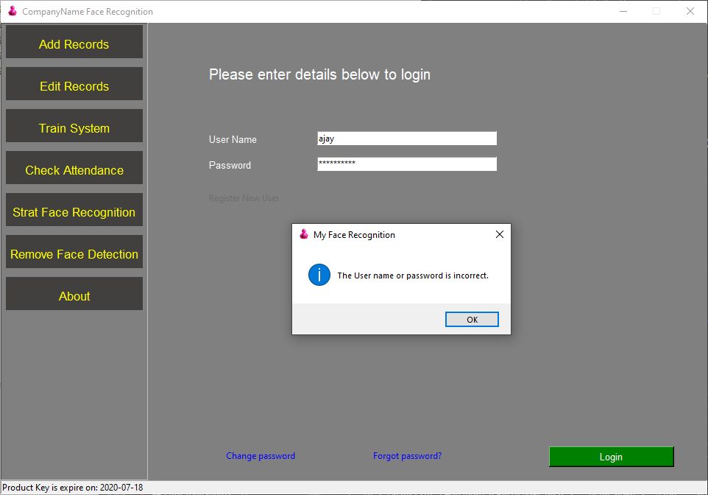

7.

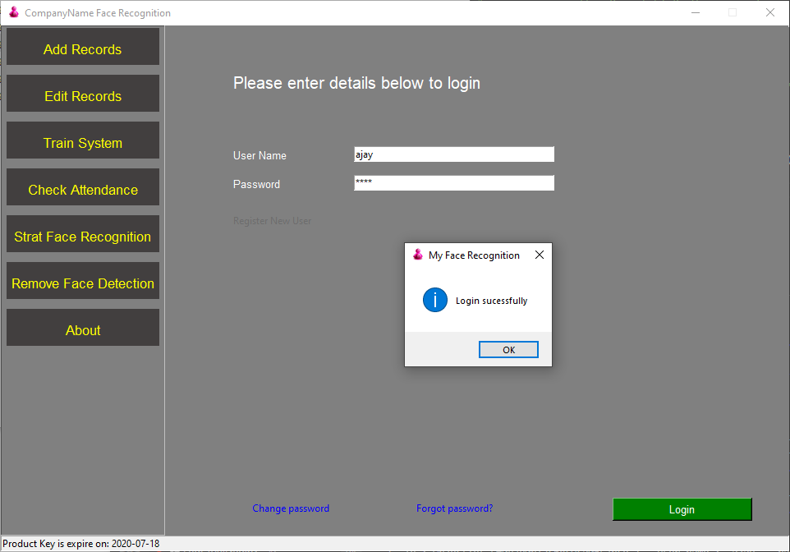

8. There is an option to change the old password.

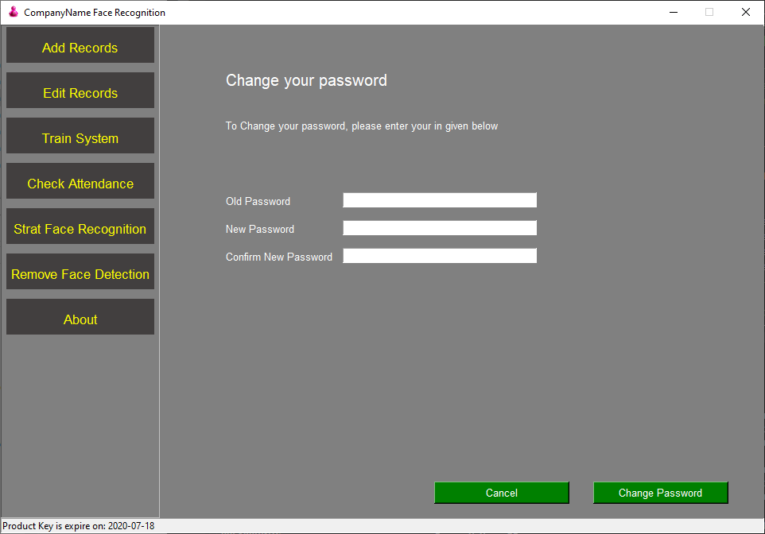

9. – **PENDING if user forgets the password, then it can be reset as follows**

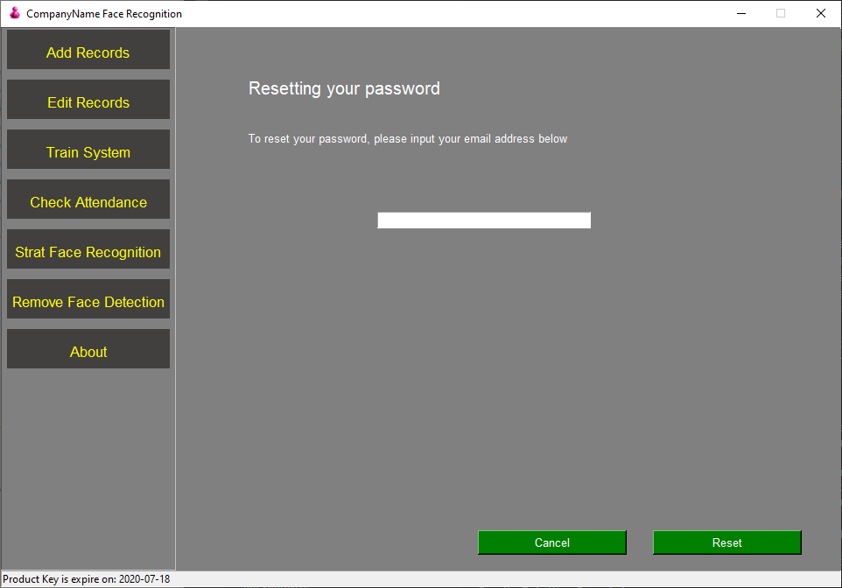

10. Validation check

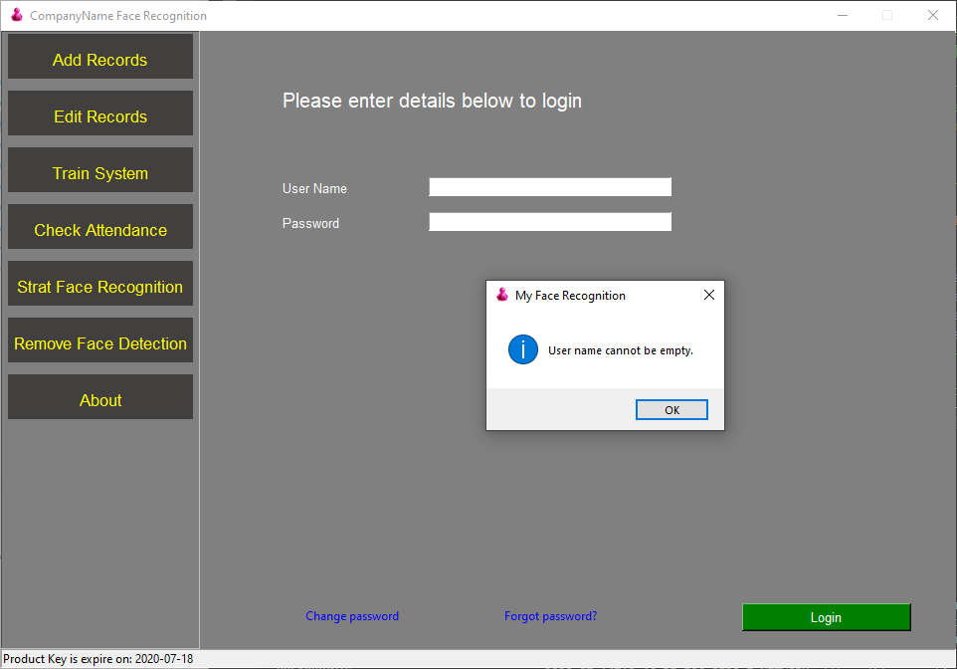

11. Add New Record - If the user tries to enter text in place of mobile number then a validation check is done on email id. etc

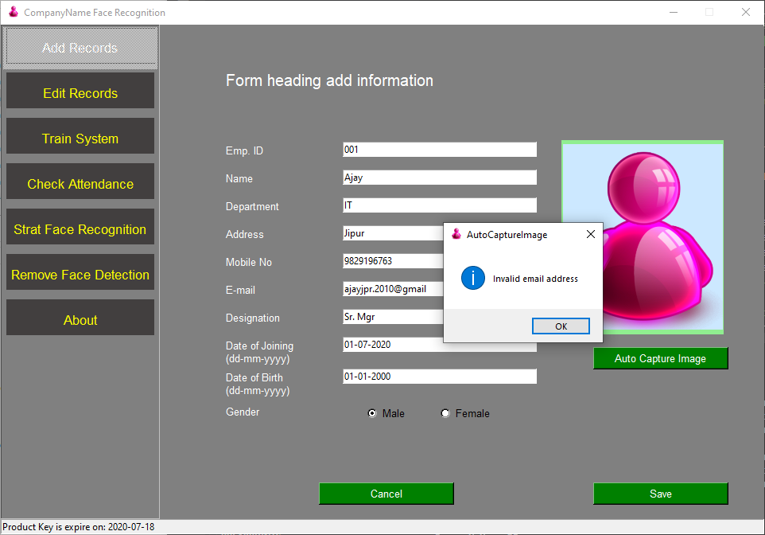

12.

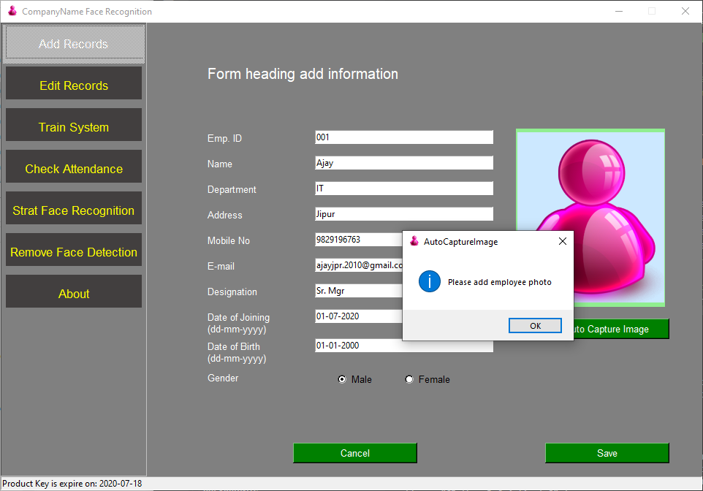

13. Steps – Auto capturing an image

**Note – Be careful during the image capturing process, follow the instructions given below -**

1. **Proper light on face during image capture**
2. **Always face come in center position of given face circle**
3. **Always take few face image from LEFT, RIGHT, UP, DOWN – Slightly tiled position as both eyes and nose properly seining in the image**
4. **Do not panic or in hurry during this process as all these images are going to our system training process, so you are requested to take neat and clear photo,**
5. **Use always good quality camera for image processing**
6. **Please open “staffImages” and cross check all capture images and if any image is dull or not clear or both eyes not clear, or face not properly come than delete all these images BEFORE system training**

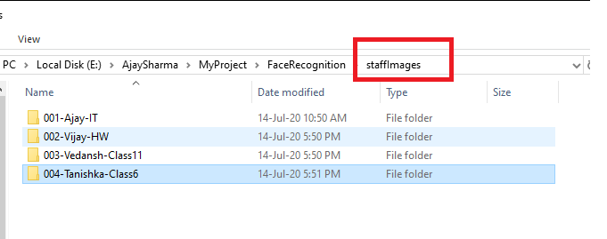

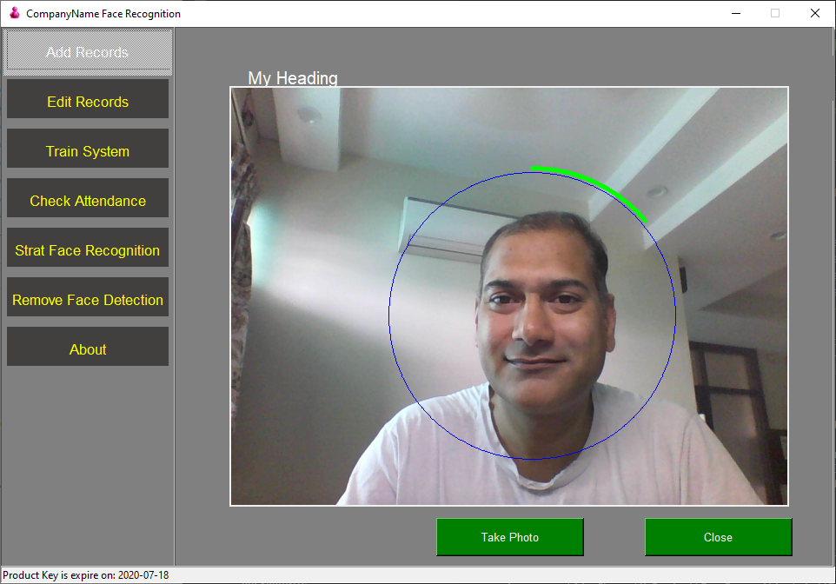

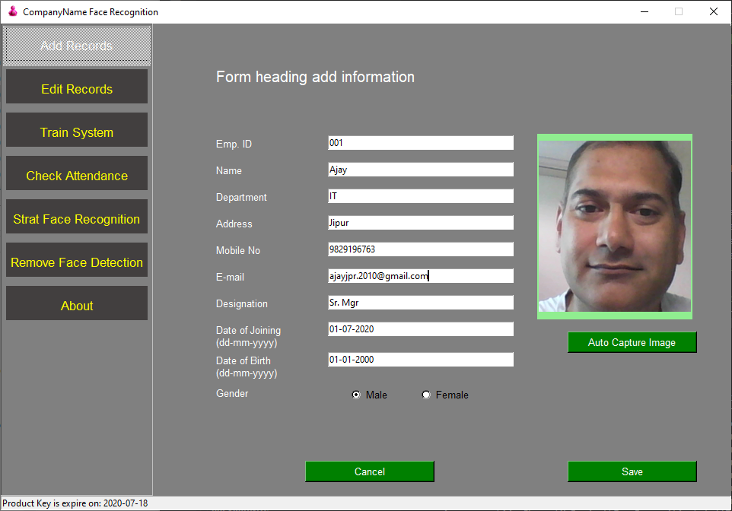

14.

15.

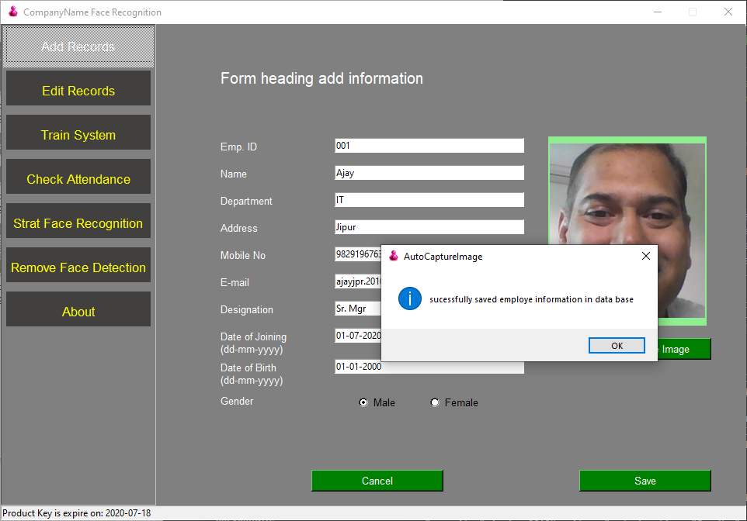

16.

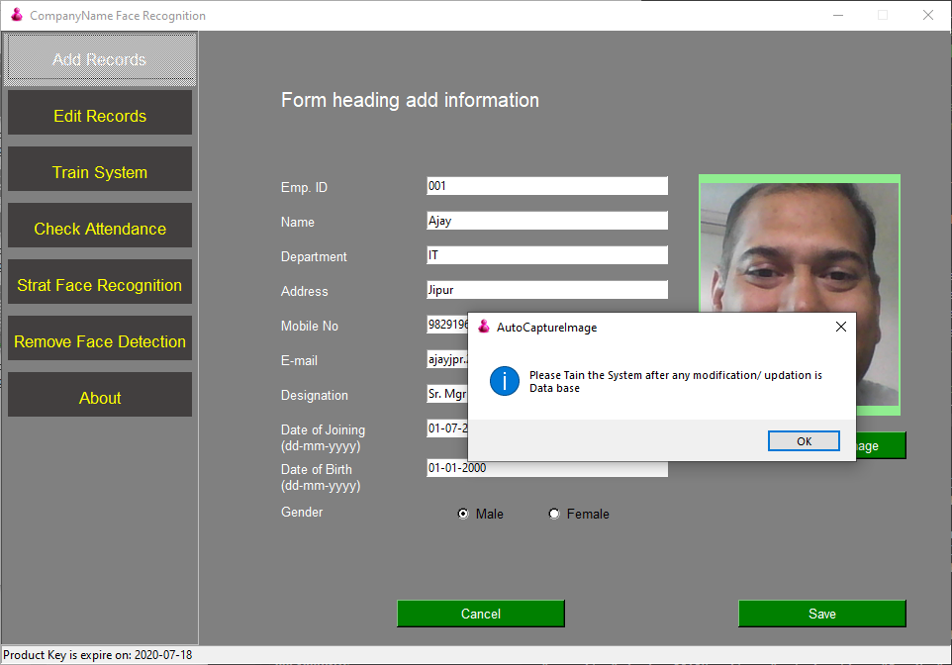

17. for editing and update any false records

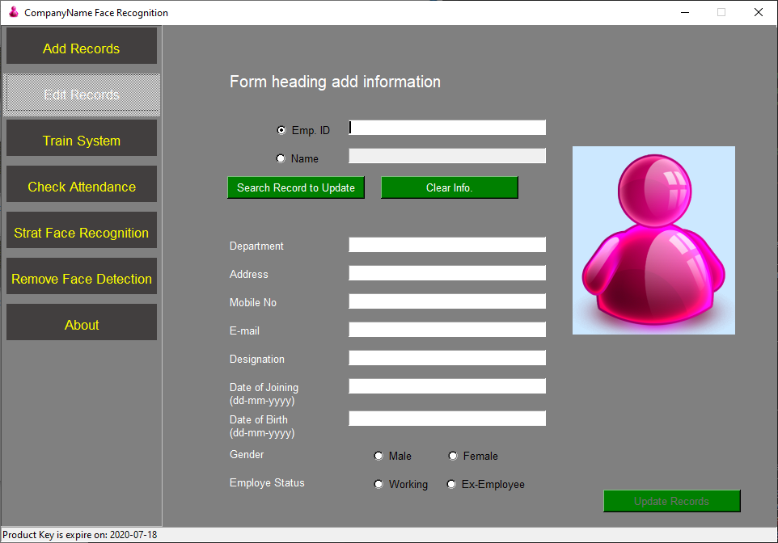

18.

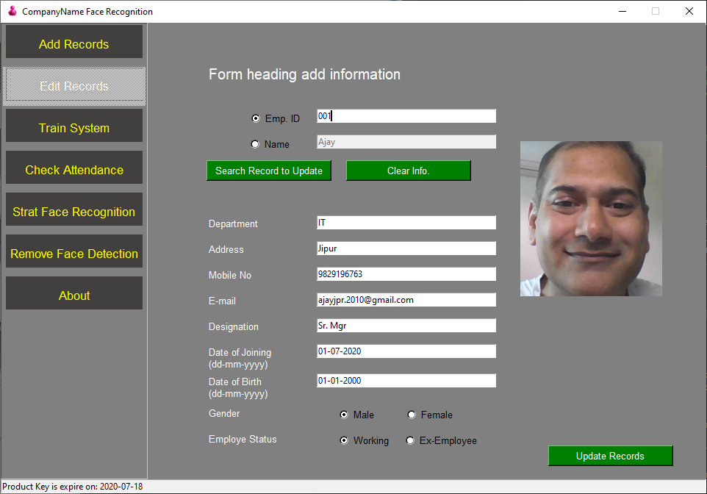

19.Tain the system as per capture images

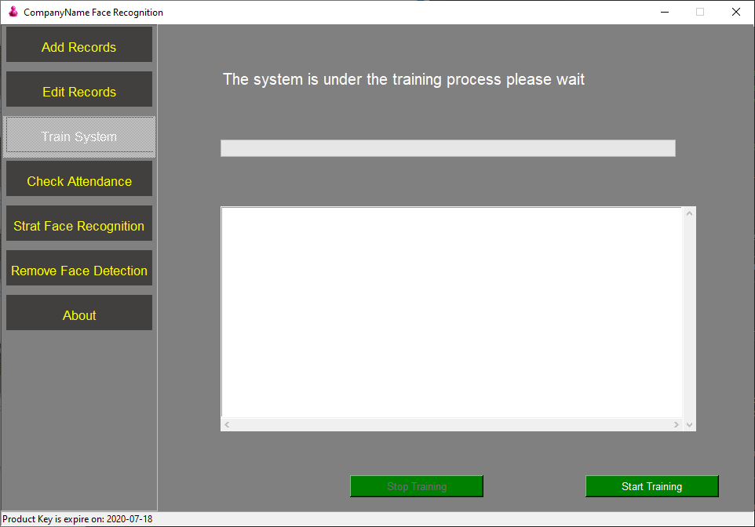

20.

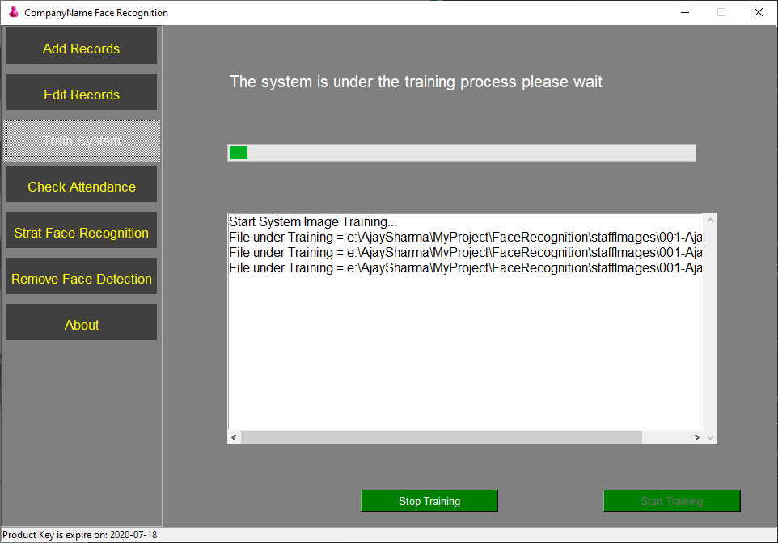

21. **if error message come after training then delete all those image from given path and again train the system.. until all images are properly processed**

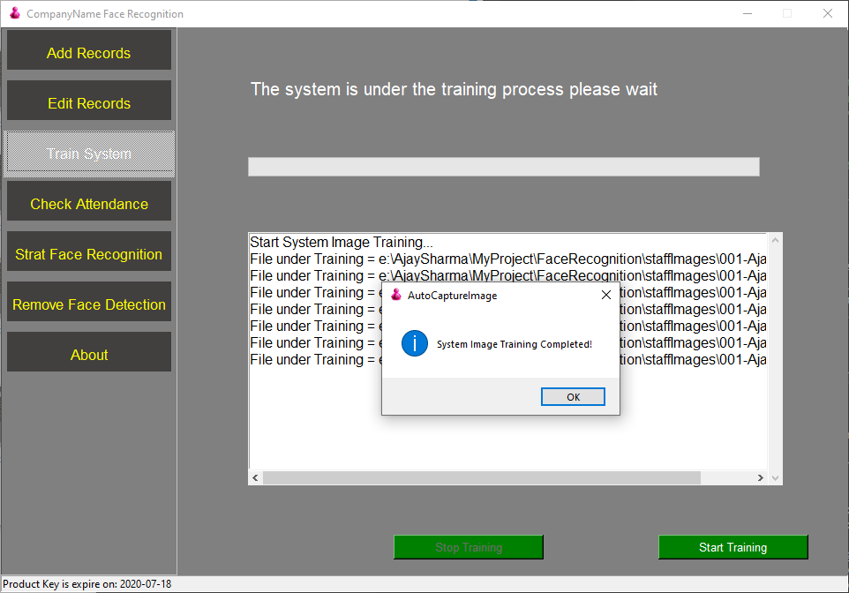

22.

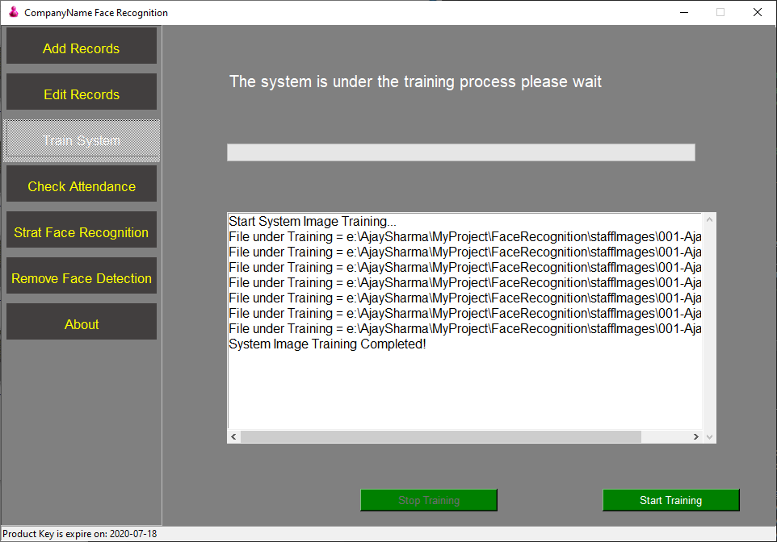

23. START our face recognition process

- Green Rectangle after attendance mark

-Red Rectangle for Unknown person

-Beep sound means your attendance is marked

-Blue rectangle around the face means more than one face in camera and

-and if more than one face in camera we don’t take attendance

-proper lighting on face for quickly recognize the face

- Attendance will be marked again, after spend 15 second of time span for already marked employee

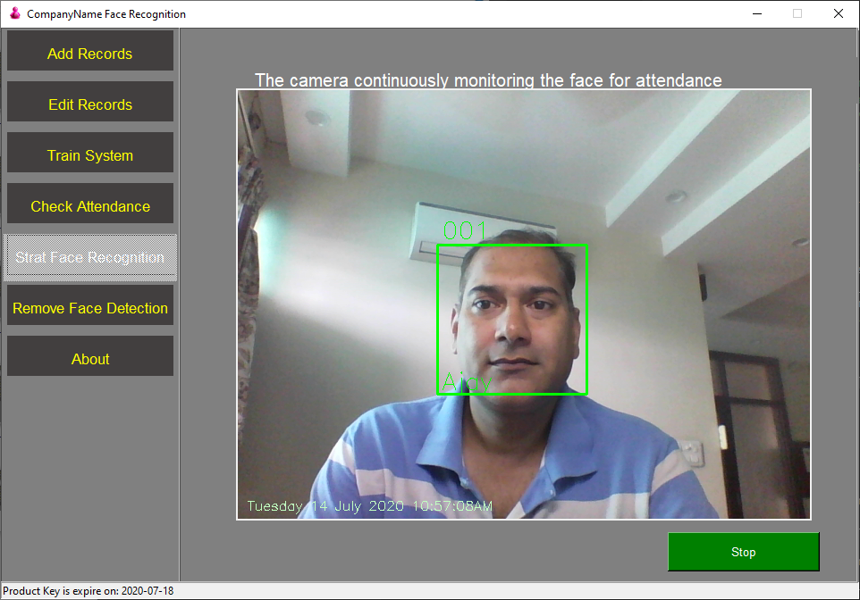

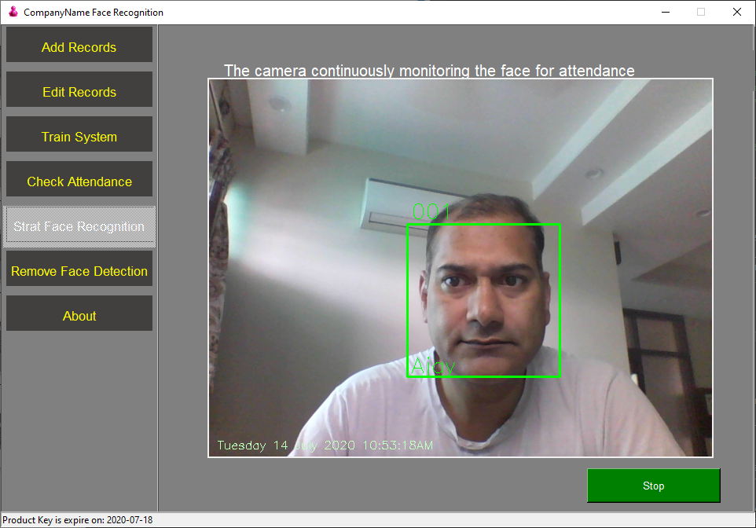

24.

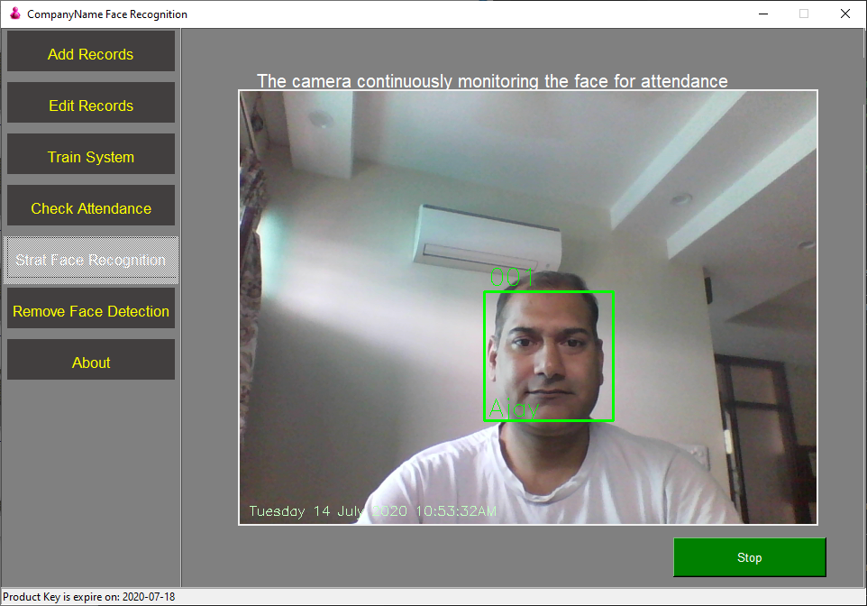

25.If you want to move to another tab first you have to stop the running camera process

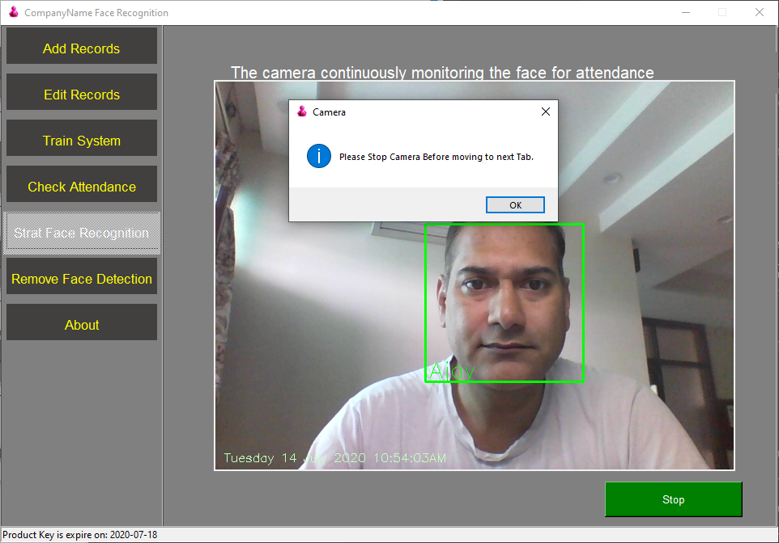

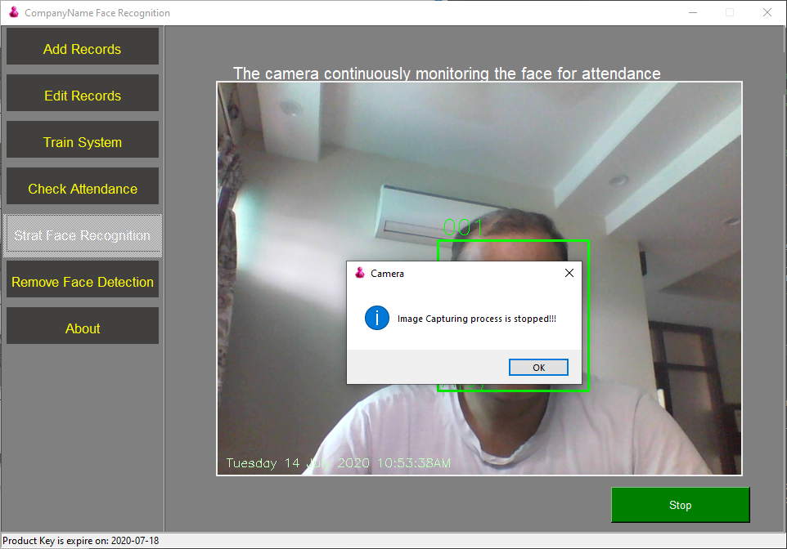

26. Check Attendance mark

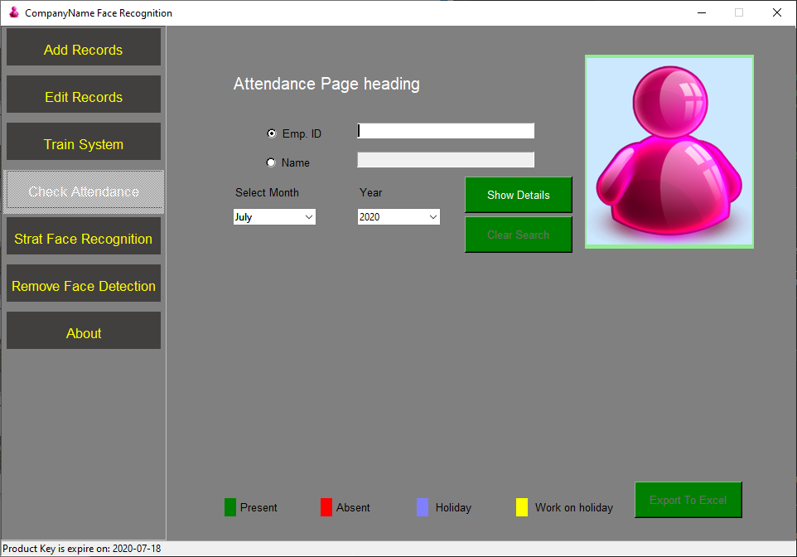

27.

After search if user exist than is Original photo will display

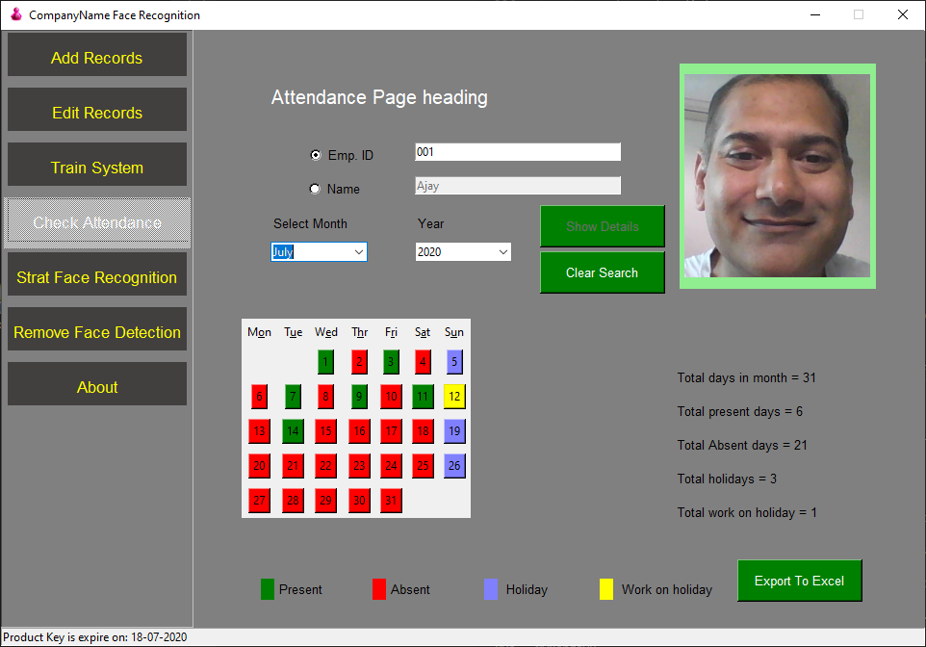

* If you click on green button of calendar than it display attendance marked photo of that Day

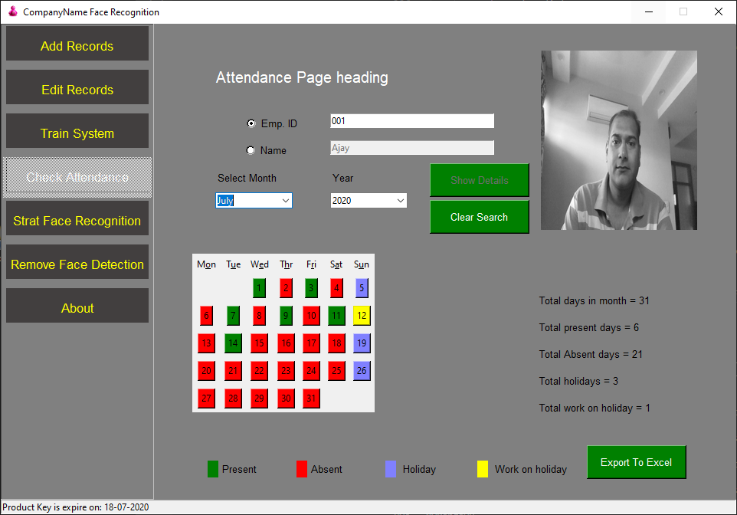

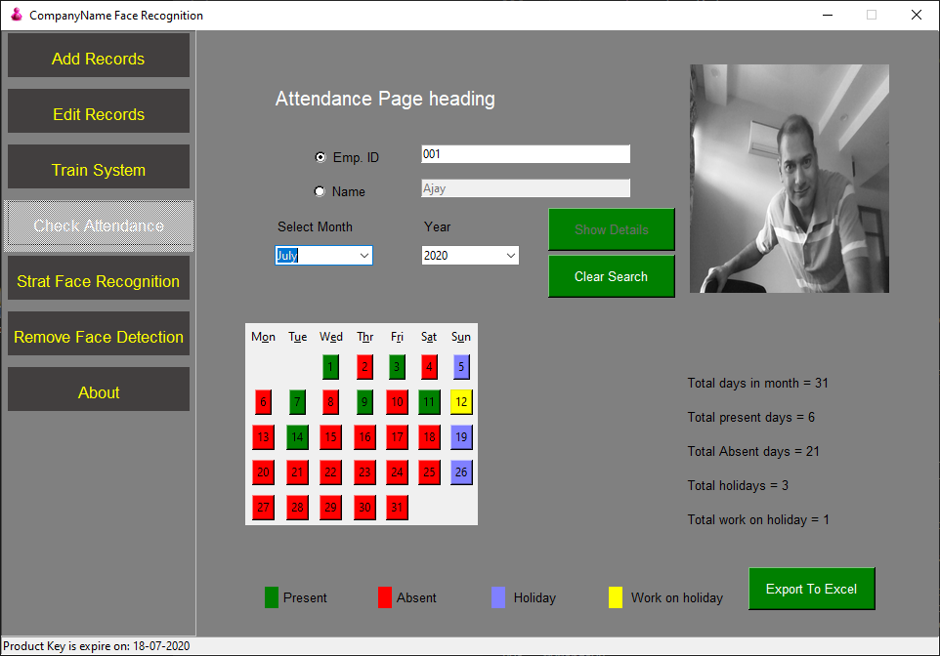

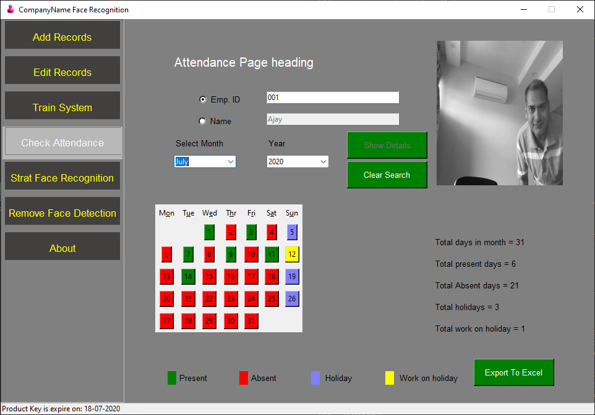

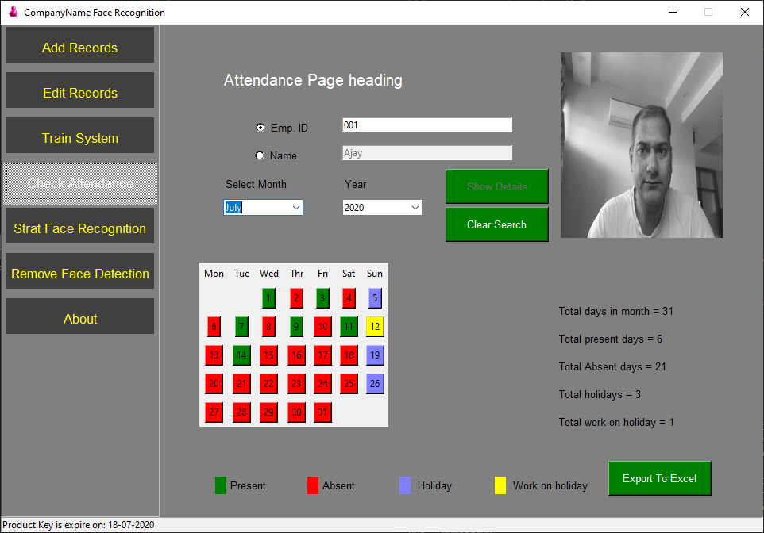

Export attendance data into excel

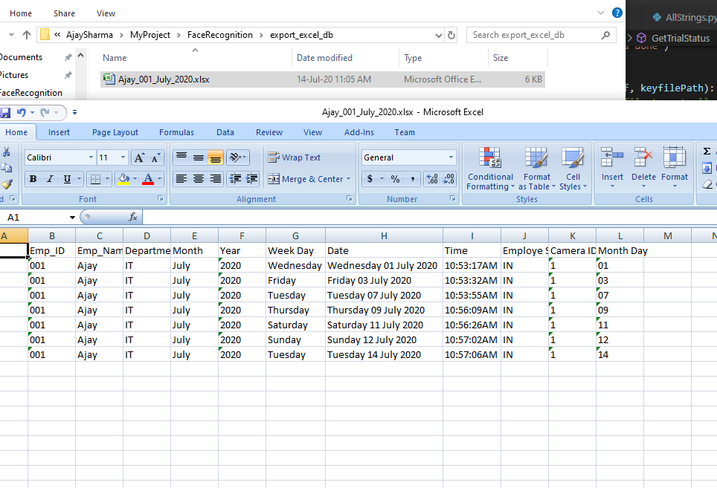

29. If Employee leave the job and we don’t want that our system still recognize his/ her face, So here we can easily remove from here and after **that Always Start System training**

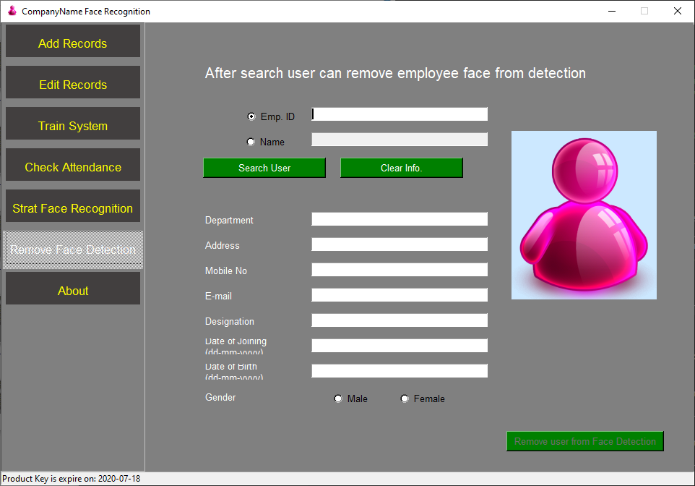

30. About

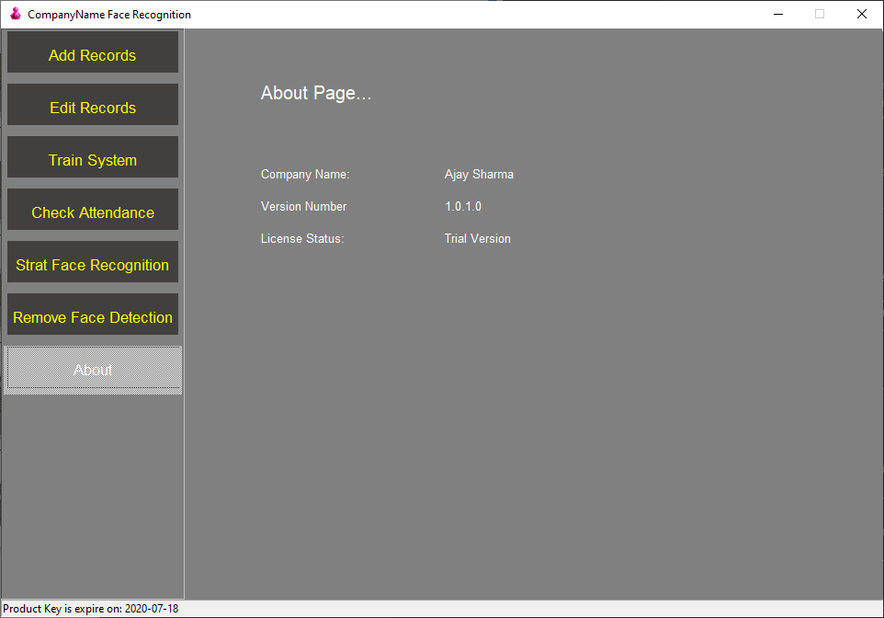

31.